NAME: Chaganti Sandeep Reddy

USN: 19MCAR0073

1.

Write a javascript program to display the current day and time.

<!DOCTYPE html>

<html>

<head>

<title>

print current day and time

</title>

</head>

<body>

<script type="text/javascript">

var myDate = new Date();

var myDay = myDate.getDay();

var weekday = ['Sunday', 'Monday', 'Tuesday',

'Wednesday', 'Thursday', 'Friday', 'Saturday'

];

document.write(" Sample output:Today is : " + weekday[myDay]);

document.write("<br/>");

var hours = myDate.getHours();

var ampm = hours >= 12 ? 'PM' : 'AM';

hours = hours % 12;

hours = hours ? hours : 12;

var minutes = myDate.getMinutes();

minutes = minutes < 10 ? '0' + minutes : minutes;

var myTime = hours + " " + ampm + " : " + minutes +

" : " + myDate.getMilliseconds();

document.write("\tCurrent time is : " + myTime);

</script>

</body>

</html>

Output:

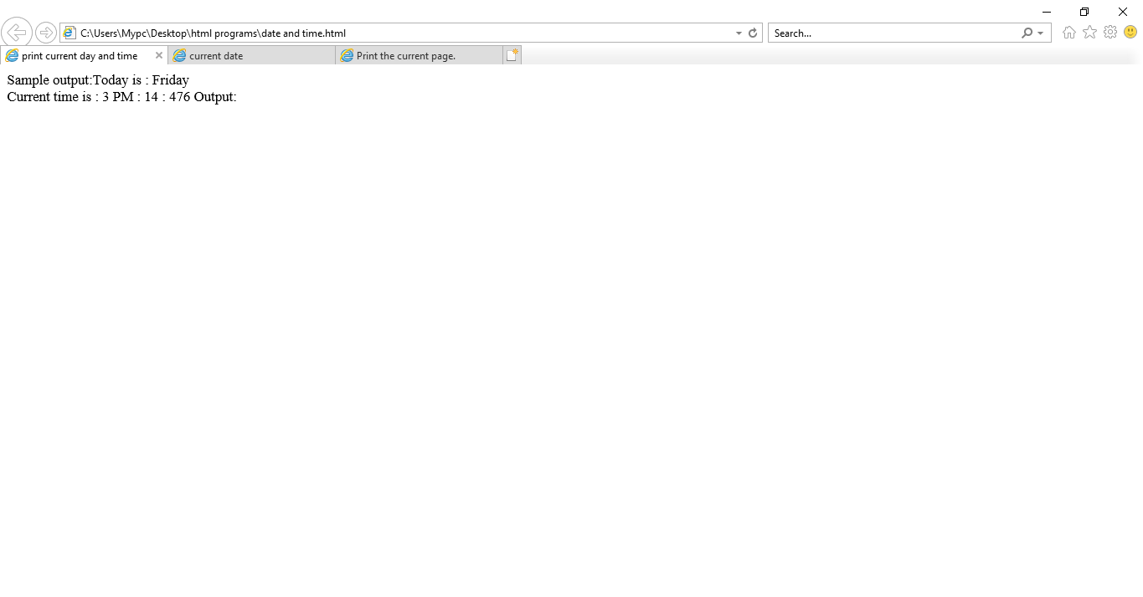

2.Write a javascript program to print the contents of the current window.

<!DOCTYPE html>

<html>

<head>

<meta charset=utf-8 />

<title>Print the current page.</title>

</head>

<body>

<p></p>

<p>Click the button to print the current page.</p>

<button onclick="print_current_page()">Print this page</button>

</body>

</html>

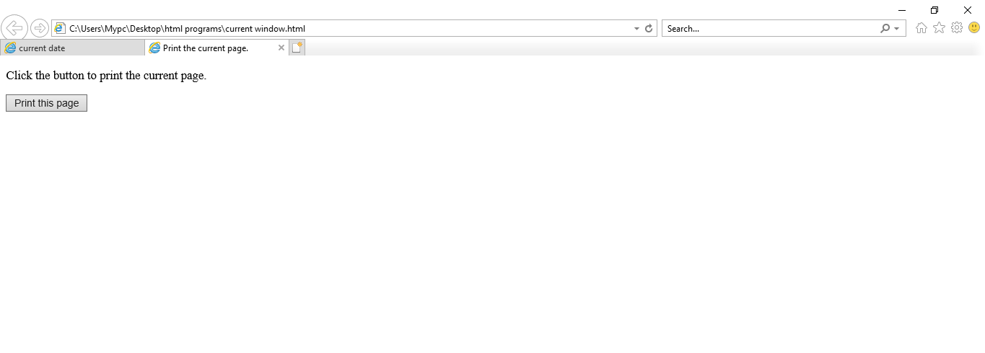

3.Write a javascript program to get the current date.

<!DOCTYPE html>

<html>

<head>

<title>

current date

</title>

</head>

<body>

<h1 style="color: green">

</h1>

<b>

current date

</b>

<p>

Current Date is:

<span class="output"></span>

</p>

<button onclick="getCurrentDate()">

Get current Date

</button>

<script type="text/javascript">

function getCurrentDate() {

let date = new Date().toDateString();

document.querySelector('.output').textContent

= date;

}

</script>

</body>

</html>

Output:

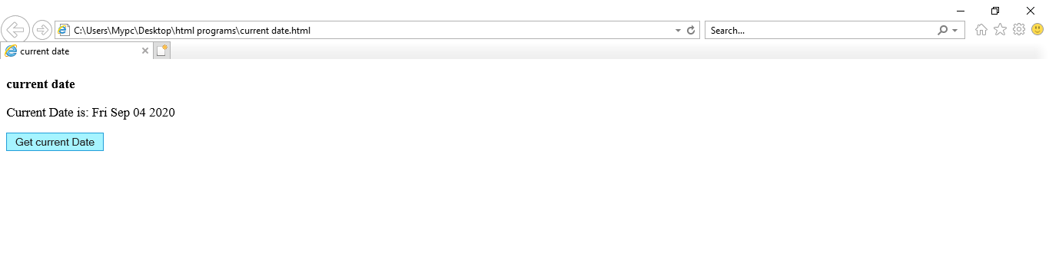

Lab 4. Write a JavaScript program to find the area of a triangle where lengths of the three of its

sides are 5, 6, 7.

Source Code:-

<!DOCTYPE html>

<html>

<head>

<meta charset=utf-8 />

<title>JS-LAB-4</title>

</head>

<body>

<script type="text/javascript">

var side1 = 5;

var side2 = 6;

var side3 = 7;

var s = (side1 + side2 + side3) / 2;

var area = Math.sqrt(s * ((s - side1) * (s - side2) * (s - side3)));

document.write("\tArea of the triangle : " + area);

</script>

</body >

</html >

Output:-

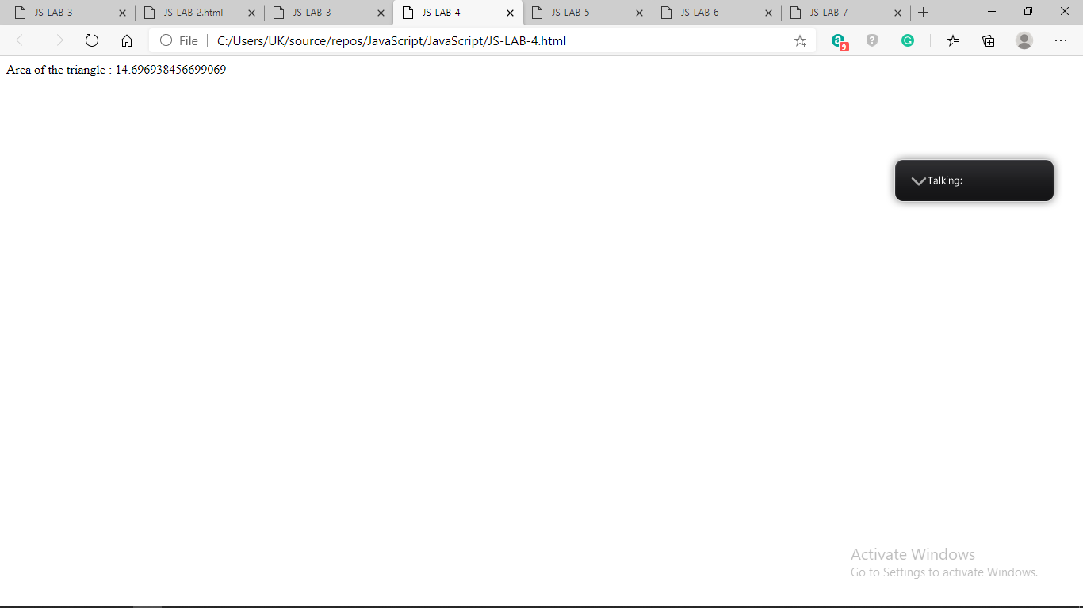

Lab 5. Write a JavaScript program to rotate the string 'w3resource' in right direction by periodically removing one letter from the end of the string and attaching it to the front.

Source Code:-

<!DOCTYPE html>

<html>

<head>

<title>JS-LAB-5</title>

<script type="text/javascript">

function animate_string(id) {

var element = document.getElementById(id);

var textNode = element.childNodes[0]; // assuming no other children

var text = textNode.data;

setInterval(function () {

text = text[text.length - 1] + text.substring(0, text.length - 1);

textNode.data = text;

}, 100);

}

</script>

</head>

<body onload="animate_string('target')"

<pre id="target">w3resource </pre>

</body>

</html>

Output:-

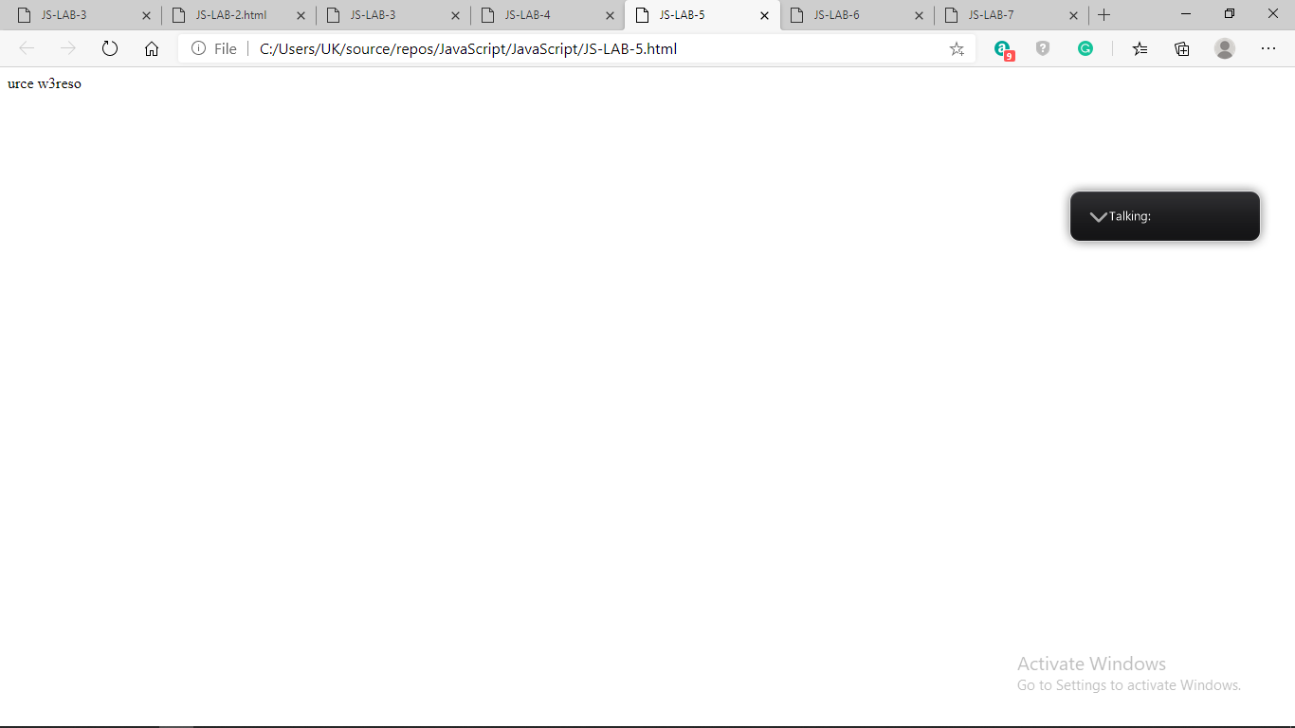

Lab 6. Write a JavaScript program to determine whether a given year is a leap year in the Gregorian calendar.

Source Code:-

<!DOCTYPE html>

<html>

<head>

<title>

JavaScript to check leap year

</title>

</head>

<body>

Input Year: <input type="text" id="year" />

<input type="button" id="button" onClick="isLeapYear()"

value="Check Leap Year">

<p id="GFG"></p>

<script>

function isLeapYear() {

var year = document.getElementById("year").value;

document.getElementById("GFG").innerHTML

= (year % 100 === 0) ? (year % 400 === 0)

: (year % 4 === 0);

}

</script>

</body>

</html>

Output:-

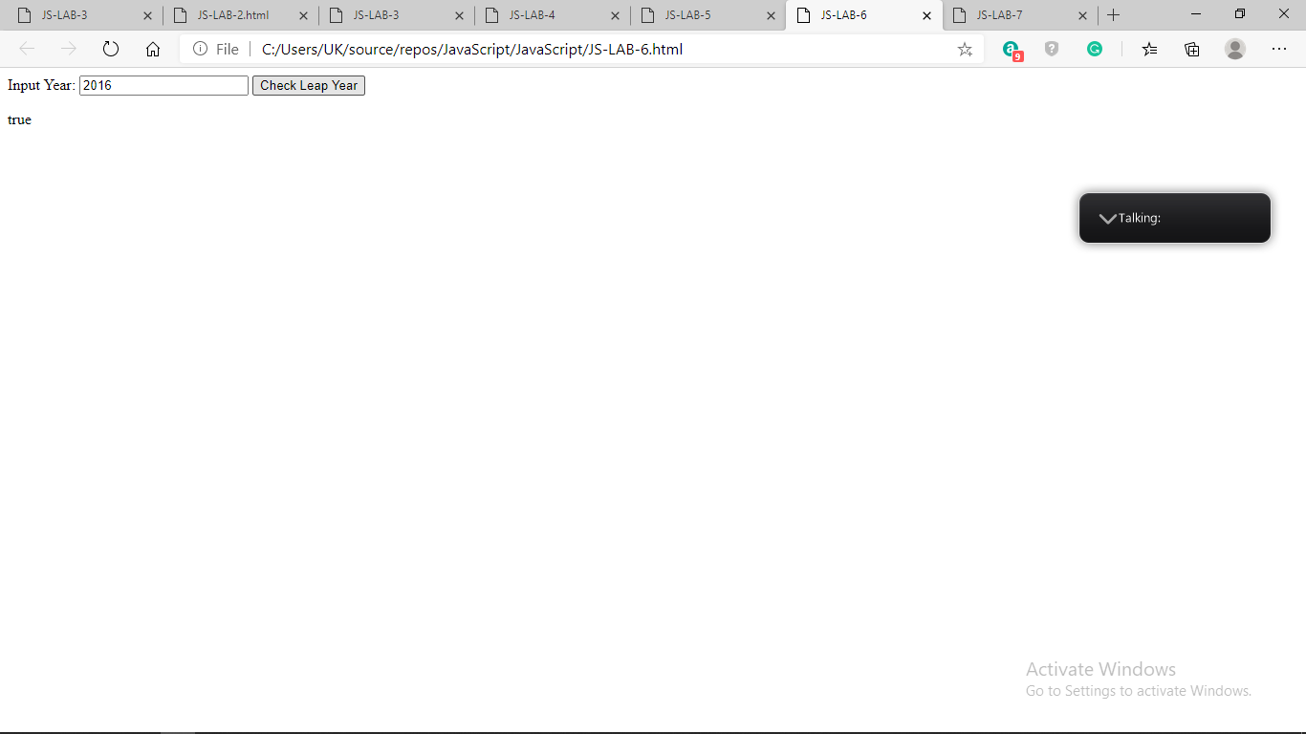

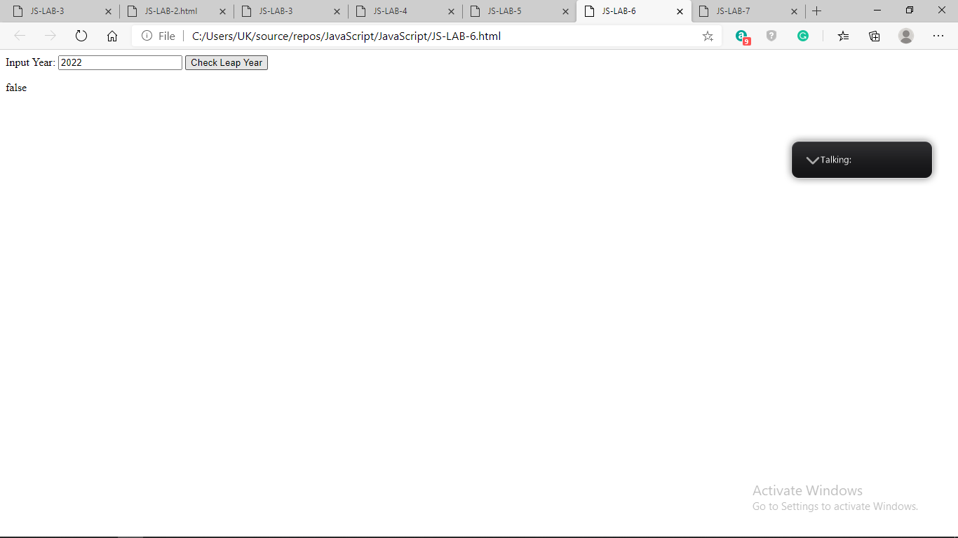

Lab 7. Write a JavaScript program where the program takes a random integer between 1 to 10, the

user is then prompted to input a guess number. If the user input matches with guess number,

the program will display a message "Good Work" otherwise display a message "Not

matched"

Source Code:-

<!DOCTYPE html>

<html>

<head>

<meta charset=utf-8 />

<title>JS-LAB-7</title>

</head>

<body>

<script type="text/javascript">

const num = Math.ceil(Math.random() * 10);

document.write(num);

const gnum = prompt('Guess the number between 1 and 10 inclusive');

if (gnum == num)

document.write("\tGoodWork : ");

else

document.write("\tNot matched " + gnum);

</script>

</body>

</html>

Output:-

